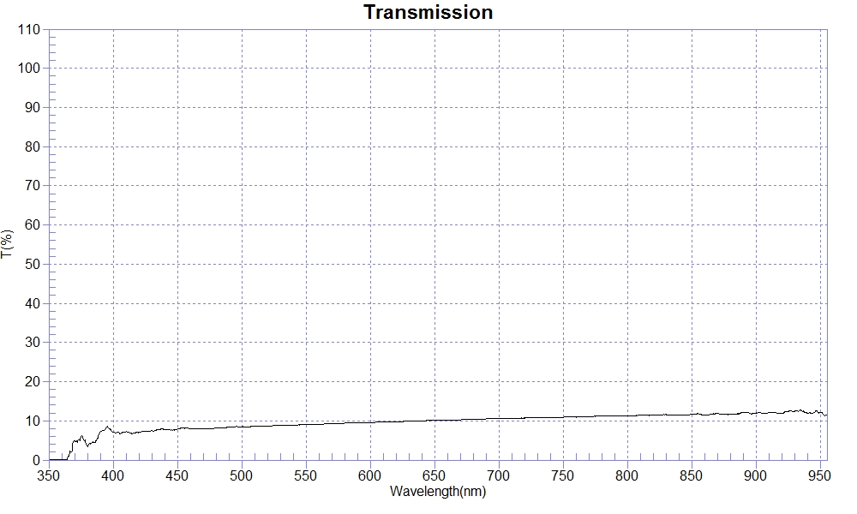
PRINT DATE :2023-02-23 上午 11:45:30
OPERATOR :PMMA
SAMPLE : #190617-6 CR T10
RANGE :400nm ～ 800nm
MAX :11.33 , 789nm MIN :6.66 , 405.2nm AVERAGE :9.56
nm | T(%) | nm | T(%) | nm | T(%)
400 | 7.03 | 510 | 8.61 | 620 | 9.81
410 | 7.22 | 520 | 8.69 | 630 | 9.91
420 | 7.04 | 530 | 8.86 | 640 | 9.99
430 | 7.53 | 540 | 8.93 | 650 | 10.10
440 | 7.85 | 550 | 9.02 | 660 | 10.20
450 | 7.85 | 560 | 9.11 | 670 | 10.26
460 | 7.94 | 570 | 9.32 | 680 | 10.40
470 | 7.96 | 580 | 9.40 | 690 | 10.51
480 | 8.14 | 590 | 9.55 | 700 | 10.56
490 | 8.36 | 600 | 9.57
500 | 8.49 | 610 | 9.72

