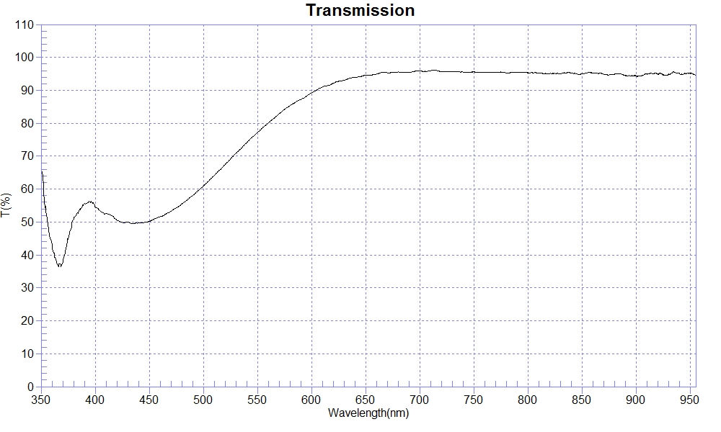
PRINT DATE :2023-01-03
OPERATOR :
SAMPLE : #201118-7 FB50
RANGE :400nm ～ 800nm
MAX :96.08 , 711.6nm MIN :49.52 , 434.9nm AVERAGE :80.93
nm | T(%) | nm | T(%) | nm | T(%)
400 | 54.69 | 510 | 64.16 | 620 | 92.15
410 | 52.52 | 520 | 67.44 | 630 | 93.08
420 | 50.55 | 530 | 70.86 | 640 | 93.90
430 | 50.05 | 540 | 74.11 | 650 | 94.67
440 | 49.66 | 550 | 77.23 | 660 | 94.91
450 | 50.18 | 560 | 80.07 | 670 | 95.37
460 | 51.63 | 570 | 82.85 | 680 | 95.56
470 | 53.23 | 580 | 85.29 | 690 | 95.40
480 | 55.47 | 590 | 87.22 | 700 | 95.92
490 | 58.00 | 600 | 89.24
500 | 60.95 | 610 | 90.98

