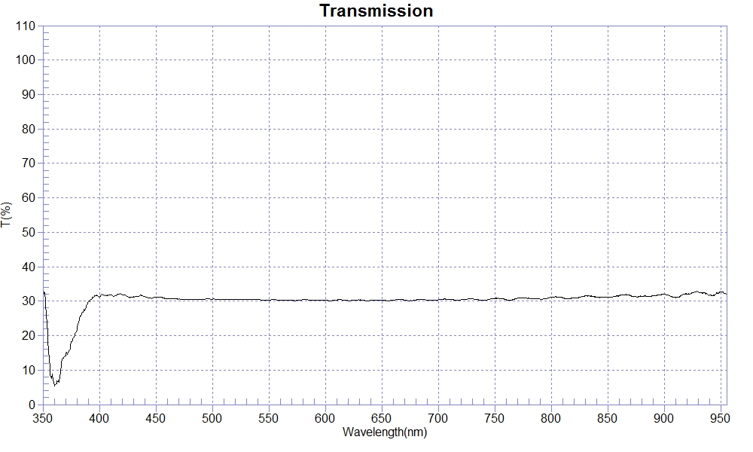
PRINT DATE :2023-02-23 上午 11:41:47
OPERATOR :PMMA
SAMPLE : #210712-1 CR T30
RANGE :400nm ～ 800nm
MAX :32.16 , 418.4nm MIN :30.12 , 603.8nm AVERAGE :30.58
nm | T(%) | nm | T(%) | nm | T(%)
400 | 31.23 | 510 | 30.49 | 620 | 30.18
410 | 31.91 | 520 | 30.56 | 630 | 30.39
420 | 31.93 | 530 | 30.56 | 640 | 30.20
430 | 31.18 | 540 | 30.45 | 650 | 30.22
440 | 31.37 | 550 | 30.29 | 660 | 30.27
450 | 31.08 | 560 | 30.24 | 670 | 30.31
460 | 30.78 | 570 | 30.31 | 680 | 30.35
470 | 30.61 | 580 | 30.43 | 690 | 30.33
480 | 30.40 | 590 | 30.21 | 700 | 30.41
490 | 30.60 | 600 | 30.27
500 | 30.59 | 610 | 30.34

