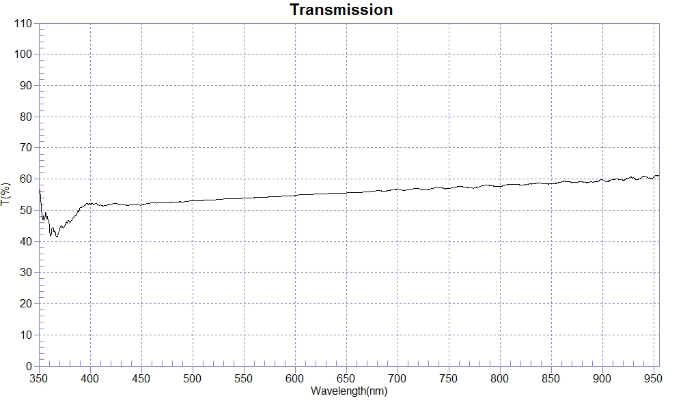
PRINT DATE :2023-02-23 上午 11:39:15
OPERATOR :PMMA
SAMPLE :#220124-2 CR T50-60
RANGE :400nm ～ 800nm
MAX :58.08 , 786nm MIN :51.22 , 412.5nm AVERAGE :54.83
nm | T(%) | nm | T(%) | nm | T(%)
400 | 51.91 | 510 | 53.14 | 620 | 55.16
410 | 51.61 | 520 | 53.35 | 630 | 55.21
420 | 51.88 | 530 | 53.58 | 640 | 55.42
430 | 52.02 | 540 | 53.73 | 650 | 55.53
440 | 51.69 | 550 | 53.85 | 660 | 55.66
450 | 51.59 | 560 | 54.00 | 670 | 55.84
460 | 52.35 | 570 | 54.07 | 680 | 56.28
470 | 52.37 | 580 | 54.29 | 690 | 56.28
480 | 52.56 | 590 | 54.67 | 700 | 56.61
490 | 52.65 | 600 | 54.71
500 | 53.06 | 610 | 54.96

