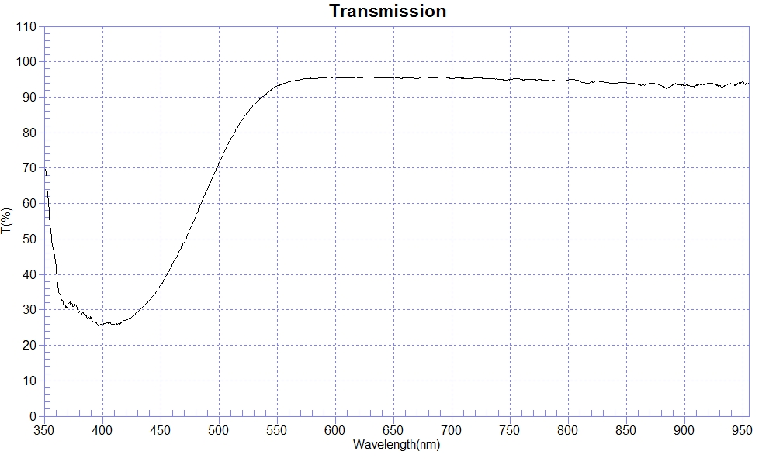
PRINT DATE :2023-01-03
OPERATOR :
SAMPLE : #221221-3 FB30
RANGE :400nm ～ 800nm
MAX :95.76 , 690.5nm MIN :25.67 , 400.3nm AVERAGE :81.79
nm | T(%) | nm | T(%) | nm | T(%)
400 | 25.79 | 510 | 78.05 | 620 | 95.54
410 | 25.93 | 520 | 83.52 | 630 | 95.62
420 | 27.12 | 530 | 87.84 | 640 | 95.52
430 | 29.31 | 540 | 90.78 | 650 | 95.55
440 | 32.53 | 550 | 93.16 | 660 | 95.42
450 | 36.88 | 560 | 94.31 | 670 | 95.26
460 | 42.77 | 570 | 94.98 | 680 | 95.57
470 | 48.93 | 580 | 95.29 | 690 | 95.72
480 | 56.25 | 590 | 95.48 | 700 | 95.27
490 | 64.07 | 600 | 95.59
500 | 71.40 | 610 | 95.44

