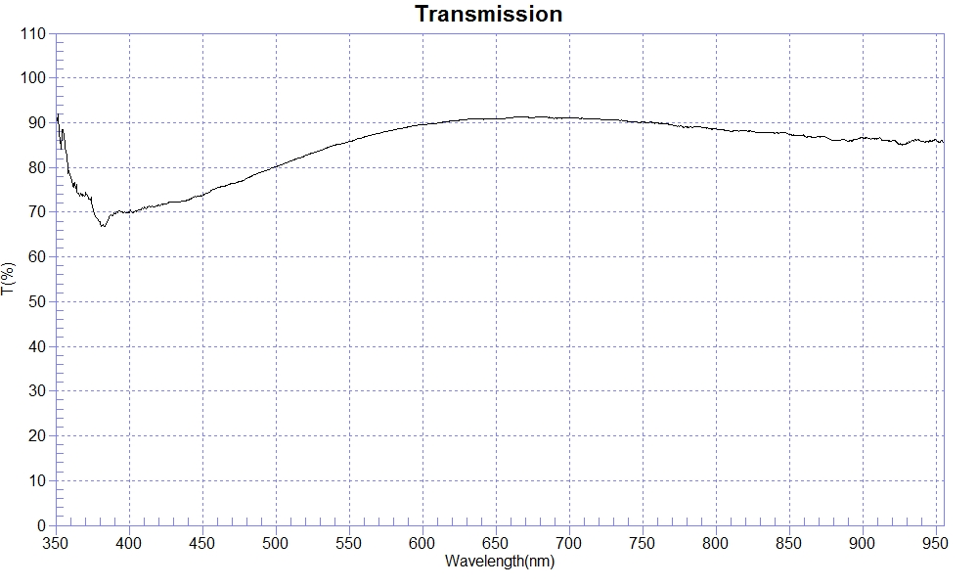
PRINT DATE :2023-01-04
OPERATOR :
SAMPLE :#230104-1 FB70
RANGE :400nm ～ 800nm
MAX :91.33 , 683.1nm MIN :69.91 , 402.3nm AVERAGE :85.62
nm | T(%) | nm | T(%) | nm | T(%)
400 | 69.84 | 510 | 81.39 | 620 | 90.36
410 | 70.99 | 520 | 82.66 | 630 | 90.73
420 | 71.54 | 530 | 83.77 | 640 | 90.78
430 | 72.33 | 540 | 84.98 | 650 | 90.91
440 | 72.71 | 550 | 85.76 | 660 | 91.07
450 | 73.74 | 560 | 86.81 | 670 | 91.25
460 | 75.46 | 570 | 87.63 | 680 | 91.28
470 | 76.40 | 580 | 88.37 | 690 | 90.99
480 | 77.48 | 590 | 89.08 | 700 | 91.04
490 | 78.95 | 600 | 89.56
500 | 80.19 | 610 | 89.87

