※※藍光抑制(440nm-480nm)FB-1報告-
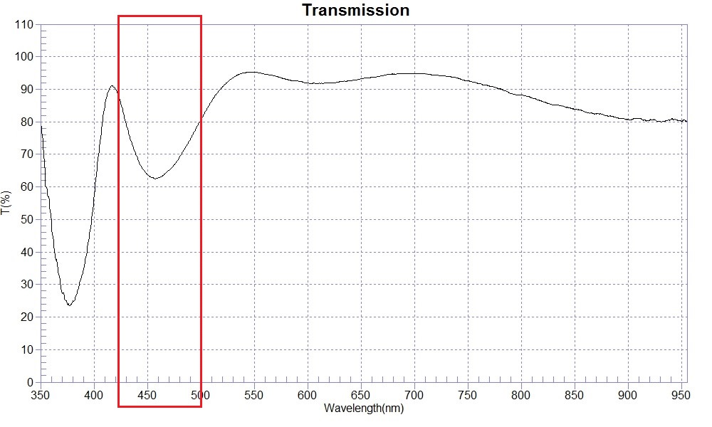
SAMPLE : 藍光抑制(440nm-480nm)FBcoating
RANGE :350nm ～ 700nm
MAX :95.28 , 544.2nm MIN :57.55 , 400.3nm AVERAGE :86.55
nm | T(%) | nm | T(%) | nm | T(%)
350 | 82.15 | 480 | 69.10 | 610 | 91.77
360 | 49.98 | 490 | 74.58 | 620 | 91.86
370 | 27.41 | 500 | 80.59 | 630 | 92.30
380 | 24.88 | 510 | 86.33 | 640 | 92.62
390 | 34.12 | 520 | 90.66 | 650 | 93.24
400 | 56.57 | 530 | 93.54 | 660 | 93.68
410 | 84.53 | 540 | 95.05 | 670 | 94.19
420 | 90.18 | 550 | 95.23 | 680 | 94.68
430 | 79.41 | 560 | 94.62 | 690 | 94.84
440 | 69.45 | 570 | 94.06 | 700 | 94.80
450 | 63.78 | 580 | 93.02
460 | 62.77 | 590 | 92.56
470 | 65.03 | 600 | 91.89

