※※全藍光波段抑制(400nm-480nm)FB-2報告
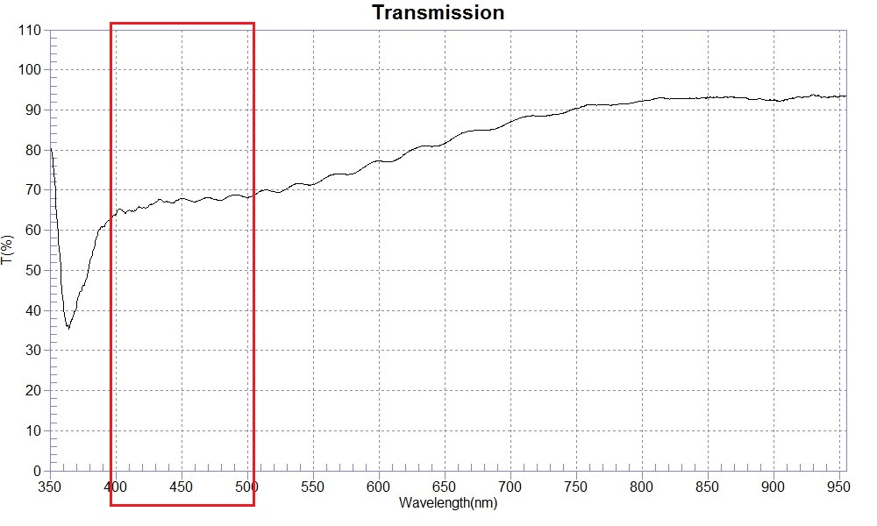
SAMPLE :全藍光波段抑制(400nm-480nm)FBcoating
RANGE :400nm ～ 700nm
MAX :87.01 , 699.9nm
MIN :63.98 , 400.3nm
AVERAGE :74.14
nm | T(%) | nm | T(%) | nm | T(%)
350 | 84.15 | 480 | 67.43 | 610 | 77.15
360 | 42.16 | 490 | 68.88 | 620 | 79.05
370 | 40.58 | 500 | 68.20 | 630 | 80.73
380 | 51.77 | 510 | 69.72 | 640 | 80.91
390 | 60.87 | 520 | 69.63 | 650 | 81.63
400 | 64.01 | 530 | 70.34 | 660 | 83.71
410 | 65.00 | 540 | 71.63 | 670 | 84.78
420 | 65.59 | 550 | 71.37 | 680 | 84.97
430 | 66.95 | 560 | 73.18 | 690 | 85.46
440 | 67.11 | 570 | 74.03 | 700 | 87.04
450 | 67.89 | 580 | 74.09
460 | 67.03 | 590 | 76.05
470 | 68.18 | 600 | 77.27

