※※單AR光譜報告
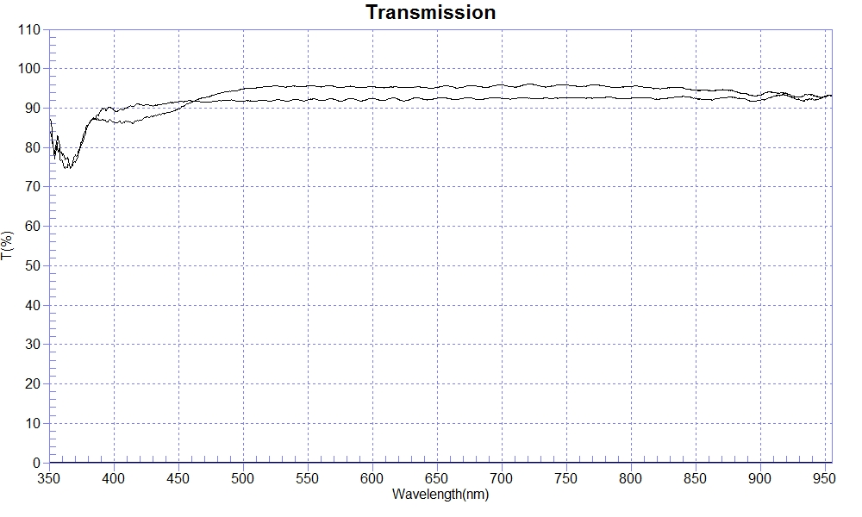
RANGE :400nm ～ 700nm
SAMPLE : pmma-0.5mm SAMPLE : pmma-0.5mm+1AR Coating
MAX :92.56 , 648nm MAX :95.87 , 699nm
MIN :89.74 , 407.2nm MIN :86.11 , 409.1nm
AVERAGE :91.84 AVERAGE :93.84
nm | T(%) | nm | T(%)
400 | 90.87 | 400 | 87.64
410 | 90.04 | 410 | 86.38
420 | 90.94 | 420 | 87.43
430 | 90.70 | 430 | 87.43
440 | 91.10 | 440 | 88.87
450 | 91.23 | 450 | 90.39
460 | 91.23 | 460 | 91.74
470 | 91.42 | 470 | 92.57
480 | 91.70 | 480 | 93.61
490 | 91.71 | 490 | 94.28
500 | 91.86 | 500 | 94.92
nm | T(%) | nm | T(%)
510 | 92.12 | 510 | 95.35
520 | 91.88 | 520 | 95.21
530 | 91.83 | 530 | 95.59
540 | 91.90 | 540 | 95.67
550 | 92.20 | 550 | 95.54
560 | 91.95 | 560 | 95.42
570 | 91.94 | 570 | 95.52
580 | 92.29 | 580 | 95.48
590 | 92.07 | 590 | 95.16
600 | 92.01 | 600 | 95.45
610 | 92.34 | 610 | 95.13
nm | T(%) | nm | T(%)
620 | 92.06 | 620 | 95.15
630 | 92.39 | 630 | 95.30
640 | 92.06 | 640 | 95.26
650 | 92.49 | 650 | 95.33
660 | 92.17 | 660 | 95.37
670 | 92.46 | 670 | 95.40
680 | 92.30 | 680 | 95.62
690 | 92.36 | 690 | 95.43
700 | 92.40 | 700 | 95.83

