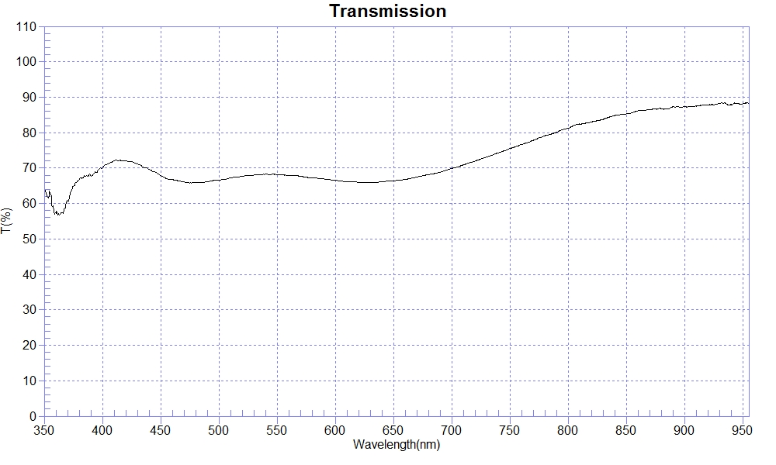
PRINT DATE :2018-03-07 上午 10:14:47
OPERATOR :
SAMPLE : 180307-1 soda glass T70%
RANGE :400nm ～ 700nm
MAX :72.37 , 411.6nm MIN :65.81 , 474.9nm AVERAGE :67.7
nm | T(%) | nm | T(%) | nm | T(%)
350 | 64.65 | 510 | 67.25 | 670 | 67.46
360 | 57.20 | 520 | 67.66 | 680 | 68.14
370 | 60.53 | 530 | 68.01 | 690 | 68.82
380 | 66.84 | 540 | 68.25 | 700 | 69.88
390 | 68.08 | 550 | 68.21 | 710 | 70.93
400 | 70.03 | 560 | 67.89 | 720 | 71.97
410 | 72.03 | 570 | 67.66 | 730 | 73.07
420 | 72.07 | 580 | 67.25 | 740 | 74.29
430 | 71.25 | 590 | 66.95 | 750 | 75.50
440 | 69.60 | 600 | 66.53 | 760 | 76.66
450 | 67.92 | 610 | 66.15 | 770 | 77.86
460 | 66.75 | 620 | 66.00 | 780 | 79.11
470 | 66.06 | 630 | 65.91 | 790 | 80.10
480 | 65.90 | 640 | 66.15 | 800 | 81.28
490 | 66.14 | 650 | 66.37
500 | 66.63 | 660 | 66.80

