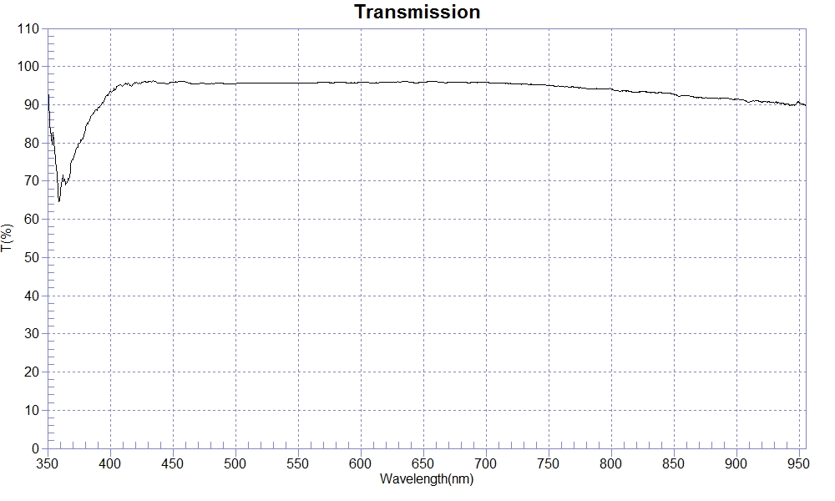
PRINT DATE :2022-10-11 下午 02:20:41
OPERATOR :
SAMPLE : 221003-4 B270 1.0 AR For420-680nm
RANGE :400nm ～ 700nm
MAX :96.22 , 434.4nm MIN :93.2 , 400.8nm AVERAGE :95.72
nm | T(%) | nm | T(%) | nm | T(%)
400 | 93.44 | 510 | 95.62 | 620 | 95.88
410 | 94.93 | 520 | 95.61 | 630 | 95.99
420 | 95.82 | 530 | 95.68 | 640 | 95.94
430 | 95.89 | 540 | 95.67 | 650 | 95.90
440 | 95.62 | 550 | 95.73 | 660 | 96.05
450 | 95.95 | 560 | 95.65 | 670 | 95.81
460 | 96.01 | 570 | 95.92 | 680 | 95.87
470 | 95.49 | 580 | 95.83 | 690 | 95.82
480 | 95.56 | 590 | 95.73 | 700 | 95.81
490 | 95.56 | 600 | 95.84
500 | 95.49 | 610 | 95.73
-

