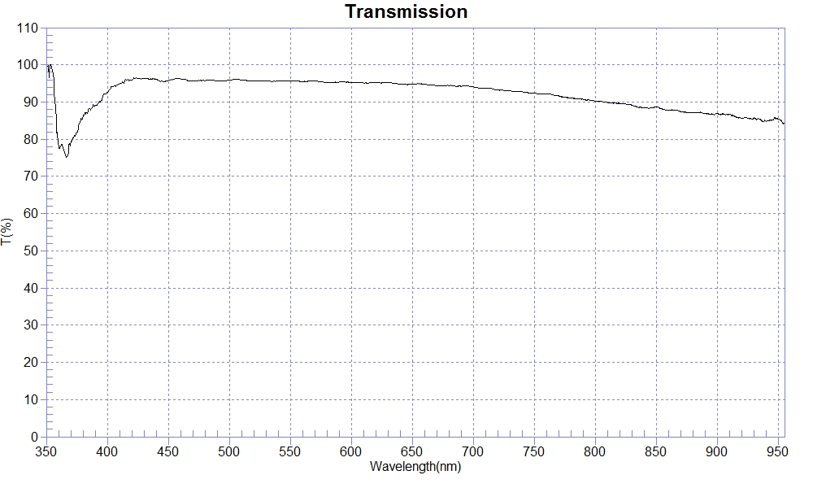
PRINT DATE :2022-10-11 下午 02:19:59
OPERATOR :
SAMPLE :221003-4 Glass1.0 AR For420-680nm
RANGE :400nm ～ 700nm
MAX :96.53 , 423.7nm MIN :92.66 , 400.3nm AVERAGE :95.35
nm | T(%) | nm | T(%) | nm | T(%)
400 | 92.68 | 510 | 95.94 | 620 | 95.22
410 | 94.97 | 520 | 95.65 | 630 | 95.23
420 | 95.92 | 530 | 95.71 | 640 | 94.88
430 | 96.26 | 540 | 95.66 | 650 | 94.75
440 | 96.15 | 550 | 95.70 | 660 | 94.83
450 | 95.78 | 560 | 95.51 | 670 | 94.41
460 | 96.20 | 570 | 95.70 | 680 | 94.44
470 | 95.72 | 580 | 95.28 | 690 | 94.21
480 | 95.76 | 590 | 95.37 | 700 | 94.06
490 | 95.74 | 600 | 95.28
500 | 95.93 | 610 | 95.13

