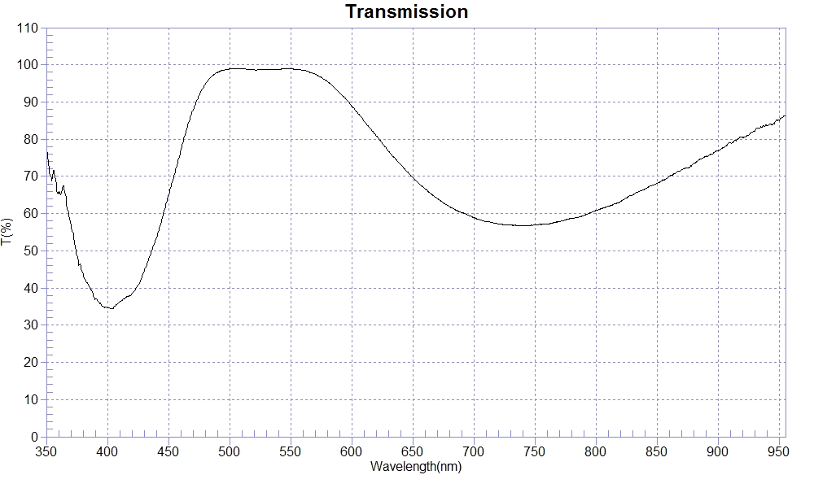
PRINT DATE :2022-12-29 上午 11:16:37
OPERATOR : :2AR Coating For 500nm-600nm #221227-5 &221228-1
SAMPLE :soda glass
RANGE :400nm ～ 800nm
MAX :98.99 , 506.7nm MIN :34.34 , 404.7nm AVERAGE :72.65
nm | T(%) | nm | T(%) | nm | T(%)
500 | 98.90 | 534 | 98.76 | 568 | 97.75
501 | 98.88 | 535 | 98.73 | 569 | 97.63
502 | 98.95 | 536 | 98.74 | 570 | 97.52
503 | 98.93 | 537 | 98.77 | 571 | 97.36
504 | 98.93 | 538 | 98.77 | 572 | 97.15
505 | 98.94 | 539 | 98.80 | 573 | 96.93
506 | 98.95 | 540 | 98.83 | 574 | 96.78
507 | 98.96 | 541 | 98.82 | 575 | 96.62
508 | 98.94 | 542 | 98.85 | 576 | 96.42
509 | 98.93 | 543 | 98.87 | 577 | 96.19
510 | 98.91 | 544 | 98.91 | 578 | 96.00
511 | 98.95 | 545 | 98.94 | 579 | 95.74
512 | 98.90 | 546 | 98.91 | 580 | 95.50
513 | 98.86 | 547 | 98.91 | 581 | 95.27
514 | 98.77 | 548 | 98.93 | 582 | 95.04
515 | 98.73 | 549 | 98.92 | 583 | 94.77
516 | 98.68 | 550 | 98.90 | 584 | 94.44
517 | 98.69 | 551 | 98.88 | 585 | 94.13
518 | 98.69 | 552 | 98.85 | 586 | 93.80
519 | 98.73 | 553 | 98.81 | 587 | 93.43
520 | 98.68 | 554 | 98.79 | 588 | 93.12
521 | 98.61 | 555 | 98.77 | 589 | 92.78
522 | 98.61 | 556 | 98.79 | 590 | 92.46
523 | 98.65 | 557 | 98.76 | 591 | 92.14
524 | 98.69 | 558 | 98.69 | 592 | 91.82
525 | 98.66 | 559 | 98.61 | 593 | 91.49
526 | 98.64 | 560 | 98.52 | 594 | 91.17
527 | 98.65 | 561 | 98.49 | 595 | 90.83
528 | 98.64 | 562 | 98.44 | 596 | 90.47
529 | 98.65 | 563 | 98.36 | 597 | 90.15
530 | 98.66 | 564 | 98.28 | 598 | 89.77
531 | 98.72 | 565 | 98.12 | 599 | 89.32
532 | 98.78 | 566 | 97.95 | 600 | 88.94
533 | 98.74 | 567 | 97.85

