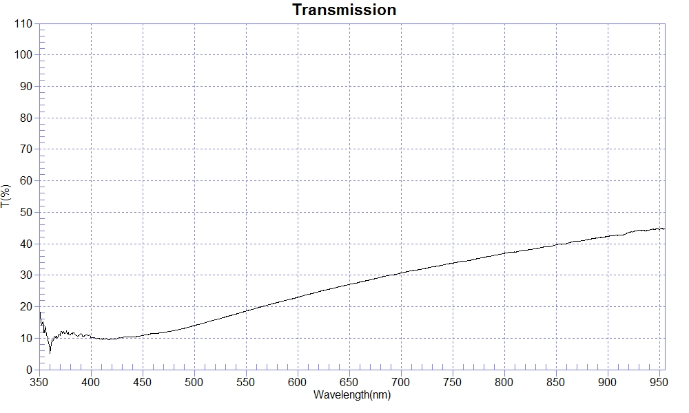
SAMPLE : NCVM-鏡面銀 穿透率T:20%
RANGE :400nm ～ 700nm
MAX :30.71 , 699.9nm MIN :9.46 , 417.9nm AVERAGE :19.27
nm | T(%) | nm | T(%) | nm | T(%)
400 | 10.12 | 510 | 14.89 | 620 | 24.72
410 | 9.80 | 520 | 15.80 | 630 | 25.52
420 | 9.72 | 530 | 16.72 | 640 | 26.34
430 | 10.17 | 540 | 17.63 | 650 | 27.10
440 | 10.43 | 550 | 18.60 | 660 | 27.80
450 | 10.79 | 560 | 19.52 | 670 | 28.52
460 | 11.46 | 570 | 20.40 | 680 | 29.32
470 | 11.69 | 580 | 21.31 | 690 | 29.99
480 | 12.42 | 590 | 22.15 | 700 | 30.73
490 | 13.07 | 600 | 23.00
500 | 14.03 | 610 | 23.90

