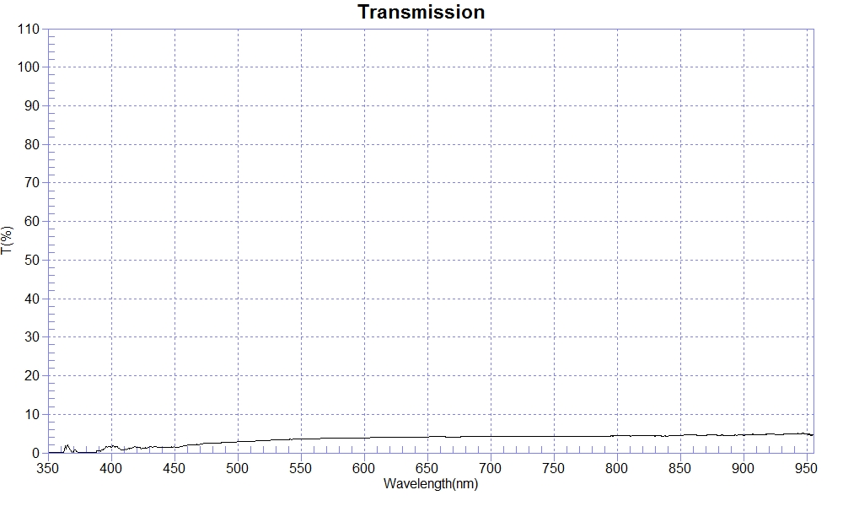
SAMPLE : NCVM-鏡面銀 穿透率T:3%
RANGE :400nm ～ 700nm
MAX :4.21 , 682.6nm MIN :0.69 , 408.6nm AVERAGE :3.2
nm | T(%) | nm | T(%) | nm | T(%)
400 | 1.50 | 510 | 3.02 | 620 | 4.00
410 | 0.78 | 520 | 3.18 | 630 | 4.10
420 | 1.38 | 530 | 3.31 | 640 | 4.10
430 | 1.56 | 540 | 3.48 | 650 | 4.13
440 | 1.38 | 550 | 3.62 | 660 | 4.17
450 | 1.50 | 560 | 3.66 | 670 | 4.09
460 | 1.98 | 570 | 3.76 | 680 | 4.19
470 | 2.19 | 580 | 3.81 | 690 | 4.18
480 | 2.48 | 590 | 3.90 | 700 | 4.17
490 | 2.69 | 600 | 3.91
500 | 2.86 | 610 | 4.02

