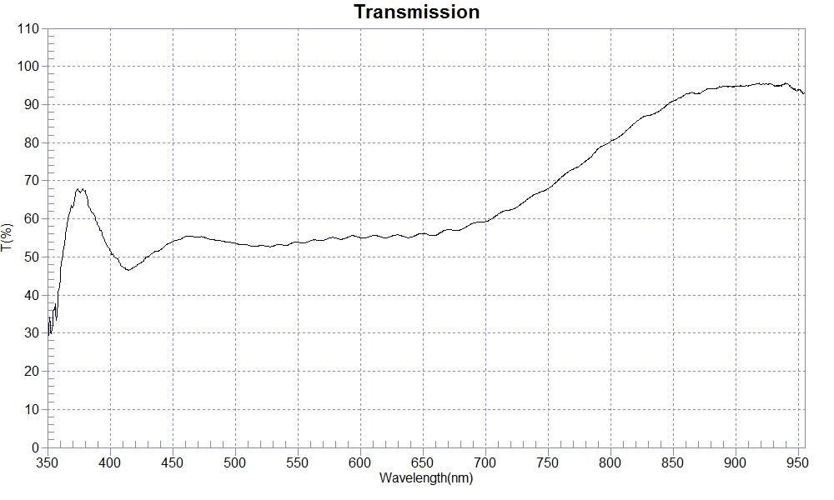
PRINT DATE :2023-03-20 下午 02:51:13
OPERATOR :
SAMPLE : T50-pmma #230320-1
T50% WL=403.74;429.54
RANGE :400nm ～ 700nm
MAX :59.28 , 699.9nm MIN :46.55 , 415nm AVERAGE :54.28
nm | T(%) | nm | T(%) | nm | T(%)
400 | 51.73 | 510 | 53.12 | 620 | 55.03
410 | 47.45 | 520 | 53.02 | 630 | 55.77
420 | 47.48 | 530 | 52.85 | 640 | 55.15
430 | 50.06 | 540 | 53.06 | 650 | 56.19
440 | 51.83 | 550 | 53.83 | 660 | 55.70
450 | 53.99 | 560 | 54.28 | 670 | 57.20
460 | 55.33 | 570 | 54.28 | 680 | 57.10
470 | 55.23 | 580 | 55.01 | 690 | 58.83
480 | 54.60 | 590 | 55.18 | 700 | 59.30
490 | 54.10 | 600 | 55.06
500 | 53.61 | 610 | 55.62

