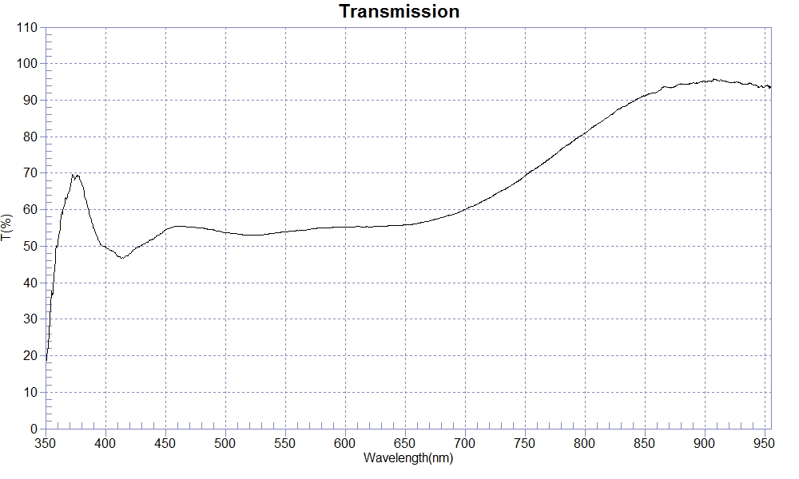
PRINT DATE :2023-03-20 下午 02:48:51
OPERATOR :
SAMPLE : T50-soda glass #230320-1
T50% WL=429.54
RANGE :400nm ～ 700nm
MAX :60.05 , 699.9nm MIN :46.78 , 413.5nm AVERAGE :54.41
nm | T(%) | nm | T(%) | nm | T(%)
400 | 49.87 | 510 | 53.35 | 620 | 55.29
410 | 47.37 | 520 | 53.00 | 630 | 55.43
420 | 47.85 | 530 | 53.06 | 640 | 55.65
430 | 50.20 | 540 | 53.52 | 650 | 55.87
440 | 51.99 | 550 | 53.94 | 660 | 56.19
450 | 54.48 | 560 | 54.25 | 670 | 56.86
460 | 55.44 | 570 | 54.57 | 680 | 57.82
470 | 55.21 | 580 | 55.00 | 690 | 58.71
480 | 54.91 | 590 | 55.12 | 700 | 60.07
490 | 54.47 | 600 | 55.22
500 | 53.76 | 610 | 55.37

