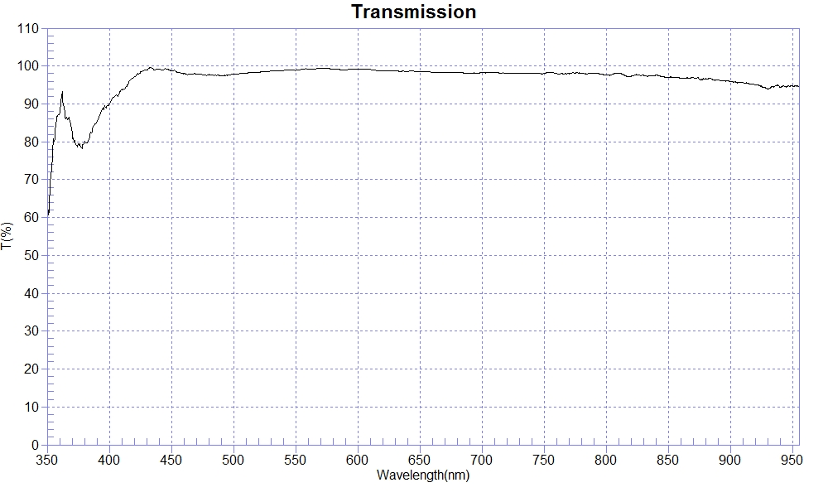
PRINT DATE :2022-11-23 下午 05:17:19
OPERATOR : 2AR :#221123-8 #221123-9
SAMPLE :soda glass
RANGE :400nm ～ 700nm
MAX :99.54 , 432.4nm MIN :97.42 , 490.4nm AVERAGE :98.57
nm | T(%) | nm | T(%) | nm | T(%)
400 | 90.09 | 510 | 98.11 | 620 | 98.73
410 | 93.72 | 520 | 98.36 | 630 | 98.78
420 | 97.10 | 530 | 98.67 | 640 | 98.62
430 | 99.06 | 540 | 98.84 | 650 | 98.53
440 | 99.17 | 550 | 98.84 | 660 | 98.30
450 | 98.82 | 560 | 99.23 | 670 | 98.30
460 | 97.99 | 570 | 99.45 | 680 | 98.32
470 | 97.82 | 580 | 99.22 | 690 | 98.03
480 | 97.73 | 590 | 99.03 | 700 | 98.20
490 | 97.46 | 600 | 99.19
500 | 97.86 | 610 | 99.11

